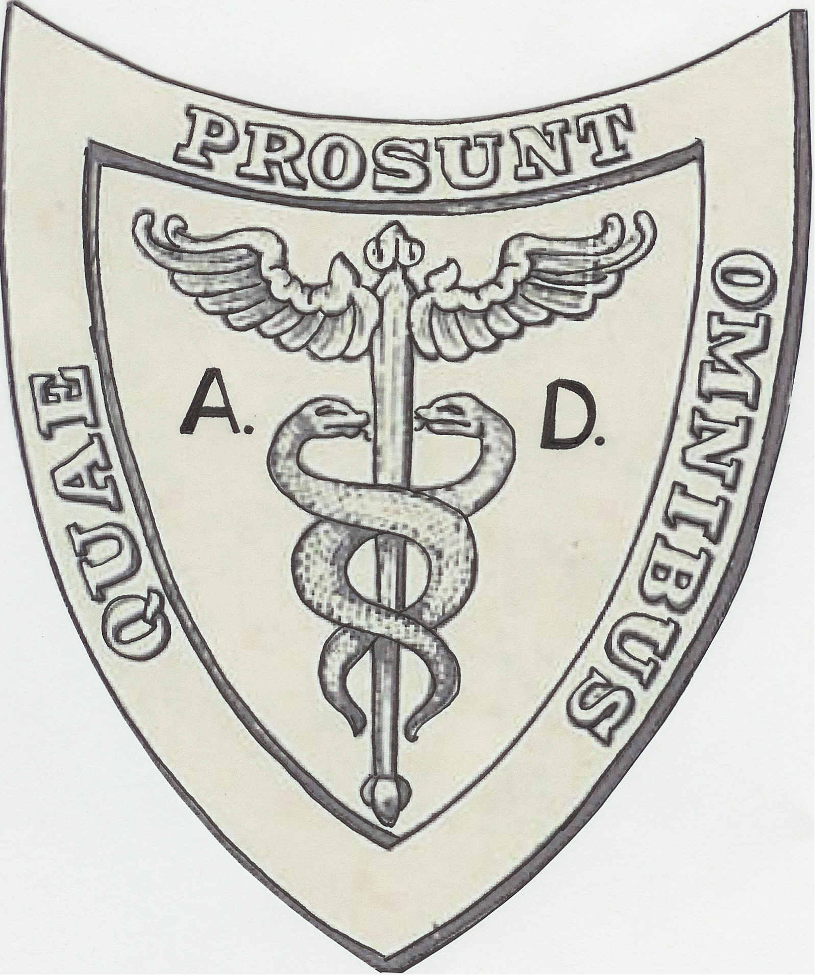
A.D.Exersize Inc. LP0059

Pneumasm Real Pain Relief System

A Million dollars of Pain Relief for under $200.00

The Pneuma Real Pain Relief System is serious health improvement for adults well into the senior years.
The Pneuma Real Pain Relief System provides you the opportunity to achieve real health benefits such as:
Relieve Low Back Pain Sacral Decompression Device
Relieve Headaches Cervical Traction Device
Improve Spinal Fluid Flow Still Point Device
Improve Lymphatic Flow Thymus Pump Device
Improve Blood Pressure Isometric Exercise Device
Remove Free Radicals Anti-Inflammatory Device

The large Magnetic Plates are set into repulsion, which guarantees they are always “on” and waiting for you to tap real healing potential.
“Muscle will tear and bone will break before the connective tissue fails!”
Release connective tissue resistance in as little as 15 minutes for a stronger, precise, and successful post adjustment.
General Directions (Refer to the video for more information):
- Lay on your back on a comfortable surface with pillows under the head and knees.
- Place the body charging band on either leg.
- Place the levitation device under the sacrum and between the shoulder blades into the most comfortable positions available and add a hand towel for more cushion as desired.
- Relax in this position for 10 to 20 min.

Warning: Pneuma Real Pain Relief System contains Strong Magnets.

